NAME: Mymoon Beevi.B REG NO: 230701201

|  |  |
| --- | --- |
| **Ex.No.: 11** | **WORK WITH JOINTS** |

# PROGRAM 1

Write a PL/SQL block to calculate the incentive of an employee whose ID is 110.

declare

a employees.employee_id%type; b employees.salary%type;

begin

Select salary into a from employees where employee_id = 110; b:=0.05*a;

dbms_output.put_line('Salary after incentive : '||(a+b)); end;

block to

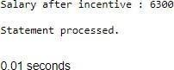

# PROGRAM 2

Write a PL/SQL show an invalid case-insensitive reference to a quoted and without quoted user-defined identifier.

declare

non_quoted_variable varchar2(10) := 'Hi'; "quoted_variable" varchar2(10) := 'Hello'; begin

dbms_output.put_line(NON_QUOTED_VARIABLE); dbms_output.put_line("quoted_variable"); dbms_output.put_line("QUOTED_VARIABLE"); end;

# PROGRAM 3

Write a PL/SQL block to

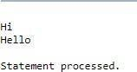

adjust the salary of the employee whose ID

122. Sample table: employees

declare old_salary employees.salary%type; new_salary employees.salary%type;

begin new_salary:= :sal;

Select salary into old_salary from employees where employee_id = 122; dbms_output.put_line('Before updation: '||old_salary);

Update employees set salary = salary + new_salary where employee_id = 122; Select salary into new_salary from employees where employee_id = 122; dbms_output.put_line('After updation: '||new_salary); end;

block to

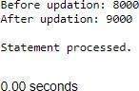

PROGRAM 4

Write a PL/SQL create a procedure using the "IS [NOT] NULL Operator" and show AND operator returns TRUE if and only if both operands are TRUE.

Create or replace procedure proc1( a boolean, b boolean) IS BEGIN

if(a is not null) and (b is not null) then if(a

= TRUE and b = TRUE) then dbms_output.put_line('TRUE'); else dbms_output.put_line('FALSE'); end if; else

dbms_output.put_line('NULL VALUES in arguments'); end if; end proc1;

BEGIN proc1(TRUE,TRUE); proc1(TRUE,FALSE); proc1(NULL,NULL);

end;

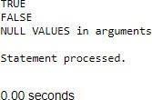describe the usage of LIKE operator including wildcard characters

and escape character.

Declare

name varchar2(20); num number(3); Begin num := :n;

Select first_name into name from employees where employee_id=num; if name like 'D%' then

dbms_output.put_line('Name starts with "D"'); end if;

if name like 'Dan_el%' then

dbms_output.put_line('Name contains "Dan" followed by one character'); end if;

name := 'Daniel_Andrea';

if name like 'Daniel\_Andrea' escape '\' then dbms_output.put_line('Name contains "Daniel_Andrea"'); end if; end;

block to

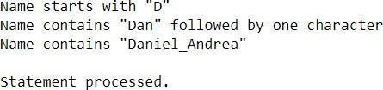

PROGRAM 6

Write a PL/SQL program to arrange the number of two variable in such a way that the small number will store in num_small variable and large number will store in num_large variable.

declare a number(2); b number(2); num_small number(2); num_large number(2);

begin a := :s;

b := :l;

dbms_output.put_line('Value in a : '||a); dbms_output.put_line('Value in b : '||b); if a>b then num_small := b; num_large

:= a; else num_small :=a; num_large :=b; end if;

dbms_output.put_line('Smaller number

is

'||num_small); dbms_output.put_line('Larger number is '||num_large); end;

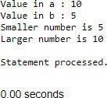

procedure to calculate the incentive on a target achieved and display the message either the record updated or not.

PL/SQL

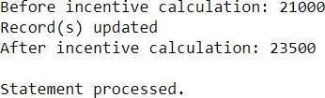

Create or replace procedure calc_incen(emp_id number,achievement number,target number)

AS

incentive number; rowcount number; Begin

achievement > target incentive:= achievement*0.2; incentive:=0; end if;

if then

else

Update employees set salary = salary + incentive where employee_id = emp_id; rowcount:= SQL%ROWCOUNT;

if rowcount>0 then dbms_output.put_line('Record(s) updated'); else

dbms_output.put_line('No Record(s) updated'); end if;

end;

Declare id

achievement

number; number;

target number; Begin id

:=

achievement

:achieve;

:target_;

:emp_id;

:=

target

:=

calc_incen(id,achievement,target); end;



PROGRAM 8

Write a procedure to calculate incentive achieved according to the specific sale limit.

PROGRAM 9

Write a PL/SQL

Create or replace procedure calc_incen(emp_id number,sales number) AS incentive number; rowcount number; Begin

if sales < 1000 then incentive:= 0;

elsif sales > 1000 and sales < 2000 then incentive := sales * 0.2; else

incentive := sales * 0.5; end if;

Update employees set salary = salary + incentive where employee_id = emp_id; rowcount:= SQL%ROWCOUNT;

if rowcount>0 then dbms_output.put_line('Record(s) updated'); else

dbms_output.put_line('No Record(s) updated'); end if; end;

Declare number; sales number; number; Begin id

:emp_id;

id

sal

:=

sales := :sale;

select salary into sal from employees where employee_id = id; dbms_output.put_line('Before incentive calculation: '||sal); calc_incen(id,sales);

select salary into sal from employees where employee_id = id; dbms_output.put_line('After incentive calculation: '||sal); end;

PROGRAM 10

Write a PL/SQL to

program count number of employees in department 50 and check whether this department have any vacancies or not. There are 45 vacancies in this department.

|  |  |
| --- | --- |
| = | 10; |
| declare emp_count number; vacancy  number := 20; begin  Select count(*) into emp_count from employees where department_id dbms_output.put_line('Total seats : '||vacancy);  dbms_output.put_line('Number of employees in Department 50 : '||emp_count); if emp_count>vacancy then  dbms_output.put_line('No vacancies available'); else dbms_output.put_line('Available vacancies : '||(vacancy-emp_count)); end if; end; |  |

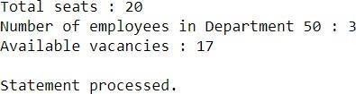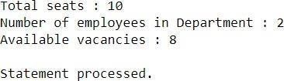

Write a PL/SQL program to count number of employees in a specific department and check whether this department have any vacancies or not. If any vacancies, how many vacancies are in that department.

PROGRAM 11

Write a PL/SQL to

declare dept_id number; emp_count number; vacancy number := 10; begin dept_id := :id;

Select count(*) into emp_count from employees where department_id = dept_id; dbms_output.put_line('Total seats : '||vacancy);

dbms_output.put_line('Number of employees in Department : '||emp_count); if emp_count>vacancy then

dbms_output.put_line('No vacancies available'); else

dbms_output.put_line('Available emp_count)); end if; end;

vacancies

:

'||(vacancy-

program display the employee IDs, names, job titles, hire dates, and salaries of all employees.

PROGRAM 12

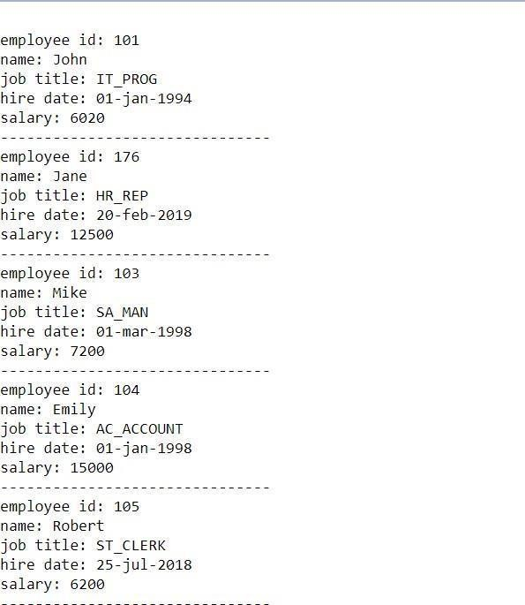

begin

for i in (select employee_id, first_name, job_id, hire_date, salary from employees) loop

dbms_output.put_line('employee id: ' || i.employee_id); dbms_output.put_line('name: ' || i.first_name); dbms_output.put_line('job title: ' || i.job_id);

dbms_output.put_line('hire date: ' || to_char(i.hire_date, 'dd-mon-yyyy')); dbms_output.put_line('salary: ' || i.salary);

dbms_output.put_line(' '); end loop;

end;

PROGRAM 13

to

Write a PL/SQL program display the employee IDs, names, and department names of all employees.

begin

for i in (select e.employee_id, e.first_name, e.job_id from employees e) loop dbms_output.put_line('employee id: ' || i.employee_id); dbms_output.put_line('name: ' || i.first_name); dbms_output.put_line('department name: ' || i.job_id); dbms_output.put_line(' ');

end loop; end;

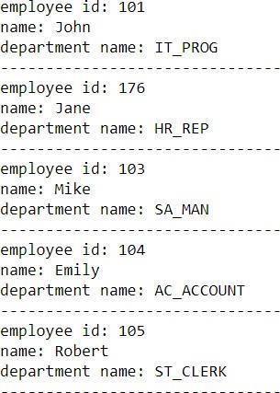

PROGRAM 13

Write a PL/SQL program display the job IDs, titles, and minimum salaries of all jobs.

Begin

for i in (select job_id,job_title,min_salary from jobs) loop

dbms_output.put_line('job id: ' || i.job_id); dbms_output.put_line('job title: ' || i.job_title); dbms_output.put_line('minimum salary: ' || i.min_salary); dbms_output.put_line(' ');

end loop; end;

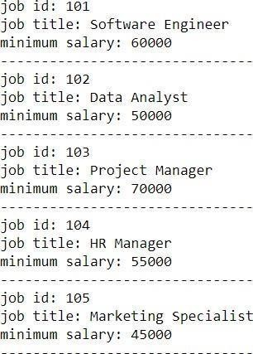to

PROGRAM 14

Write a PL/SQL program display the employee IDs, names, and job history start dates of all employees.

Begin

for i in (select employee_id,employee_name,start_date from job_history) loop dbms_output.put_line('employee id: ' || i.employee_id); dbms_output.put_line('name: ' || i.employee_name); dbms_output.put_line('start date: ' ||to_char(i.start_date, 'dd-mon-yyyy')); dbms_output.put_line(' '); end loop; end;

to

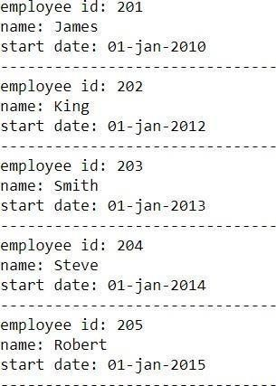

PROGRAM 15

Write a PL/SQL program to display the employee IDs, names, and job history end dates of all employees.

Begin for i in (select employee_id,employee_name,end_date from job_history) loop

dbms_output.put_line('employee id: ' || i.employee_id); dbms_output.put_line('name: ' || i.employee_name); dbms_output.put_line('end date: ' ||to_char(i.end_date, 'dd-mon-yyyy')); dbms_output.put_line(' '); end loop; end;

